Spelling in Year 6
A Parent Booklet

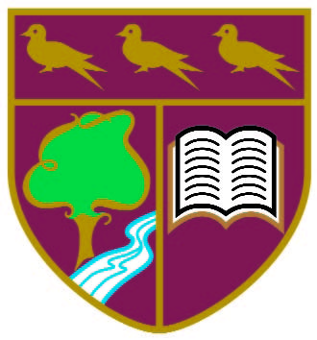

Pound Hill Junior School
Aims of this booklet:
- To increase understanding of the spelling expectations of the National Curriculum in Year 6
- To familiarise yourself with effective methods and strategies to support spelling at home

Year 6 National Curriculum requirements
Pupils should be taught to:
• develop a range of personal strategies for learning new and irregular words
• develop a range of strategies for checking and proof reading spellings after writing
• use further prefixes and suffixes and understand the guidance for adding them
• spell some words with ‘silent’ letters (for example, knight, psalm, solemn)
• continue to distinguish between homophones and other words which are often confused
• use knowledge of morphology and etymology in spelling and understand that the spelling of some words needs to be learnt specifically
• use dictionaries to check the spelling and meaning of words
• use the first three or four letters of a word to check spelling, meaning or both of these in a dictionary
• use a thesaurus
• proofread for spelling errors

The word-list for years 5 and 6 (appendix 1) is statutory – by the end of KS2, children are required to know how to spell these words. The list is a mixture of words pupils frequently use in their writing and those which they often misspell. Some of the listed words may be thought of as quite challenging, but the 100 words in the list can easily be taught within the four years of key stage 2 alongside other words that teachers consider appropriate.

How spelling is taught at Pound Hill Junior School
At Pound Hill we use the ‘No Nonsense Spelling Programme’. The focus of the programme is on the teaching of spelling, which embraces knowledge of spelling conventions – patterns and rules; but integral to the teaching is the opportunity to promote the learning of spellings, including statutory words, common exceptions and personal spellings.
Pupils regularly work in their spelling journals which we feel benefits them in many ways. They enable:
- Pupils to take responsibility for their spelling learning
- Pupils to refer back to previous learning
- Teachers to see how pupils are tackling tricky elements of spelling
- To allow pupils to experiment with language and the construction of vocabulary

In Year 6, Spelling journals are used for:
- Practising spelling strategies
- Learning the meaning of new vocabulary
- Recording rules/conventions/generalisations of spelling patterns
- Word lists
- ‘Having a go’ sheets where children can experiment with spelling more challenging words
- On-going record of words learnt
- Language investigations
- Learning the etymology of words
- Spelling tests

Learning spellings at home
Learning needs to happen at school and at home. Learning at home needs to be an extension of the practice in school. Parents and carers should consider:
- Limiting the number of words to practise each week to ensure success and enable a deeper learning
- Encouraging children to use the strategies they have learnt in school when practising at home
- Assessing spellings in context, for example: learning spellings in a given sentence, generating sentences for each word, assessing through unseen dictated sentences

Examples of learning strategies:
- Look, say, cover, write, check –
- Look: first look at the whole word carefully and if there is one part of the word that is difficult, look at that part in more detail
- Say: say the word as you look at it
- Cover: cover the word
- Write: write the word from memory, saying the word as you do so
- Check: Have you got it right? If yes, try writing it again and again! If not, start again – look, say, cover write, check!

- Quickwrite – Writing the words linked to the teaching focus with speed and fluency. The aim is to write as many words with a time constraint.

- Drawing around the word to show the shape - Draw around the words making a clear distinction in size where there are ascenders and descenders. Look carefully at the shape of the word and the letters in each box. Now try to write the word making sure that you get the same shape.

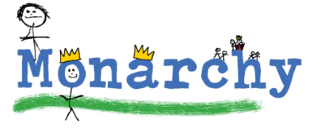
- Drawing an image around the word - Make the word memorable. It links to meaning in order to try to make the spelling noticeable.

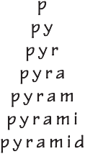
- Pyramid Words – This method of learning forces you to think of each letter separately.

- Rainbow Writing - Use coloured pencils to make parts of the spelling words memorable. You could highlight the tricky parts of the word or write the tricky parts in a different colour.

Appendix 1 – Year 5 & 6 Spelling List

