

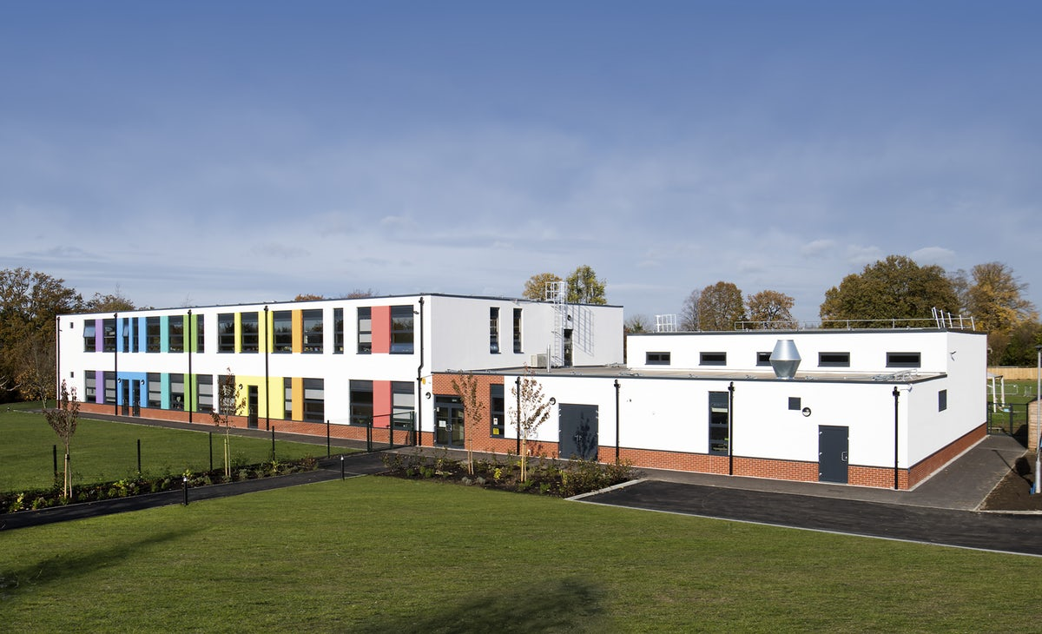

POUND HILL JUNIOR SCHOOL

MY NEW SCHOOL

BY _________________

Great news! You are coming to Pound Hill Junior School in September. You are going to learn lots when you come here and enjoy all the things we have planned for you.

We know it can be a bit scary when things change, so to help you we have created this booklet.

You won’t know what to write on some of the pages yet but you will be able to make a start. As you get to know the school over the next few weeks you can add more!

We are hoping that you have lots of questions for us – ask your teachers to send these to us and we will get the Year 3 children to write back to you with all the answers.

We can’t wait to meet you!

It is normal to feel sad and nervous when things change. However, change can also be exciting.

How are you feeling about starting Pound Hill Junior School in September?

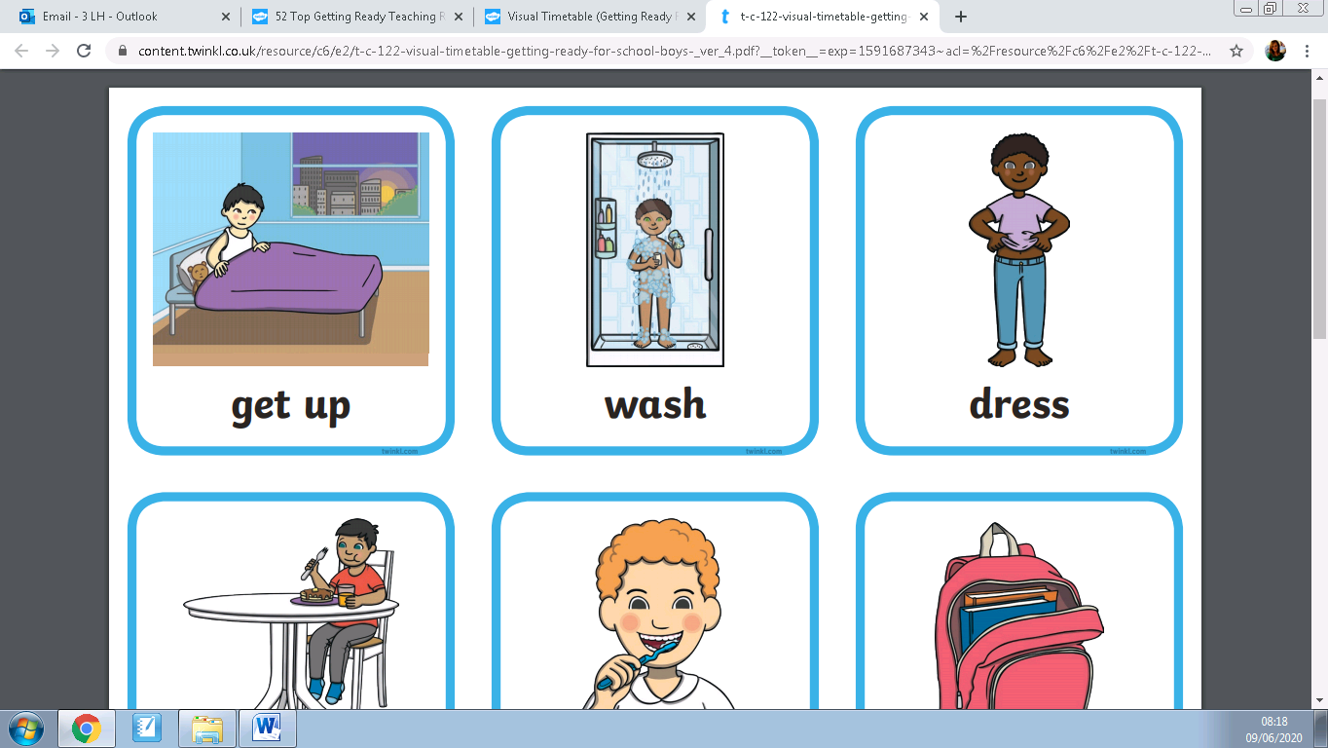Whilst there is some change, LOTS of things will also **stay the same**.

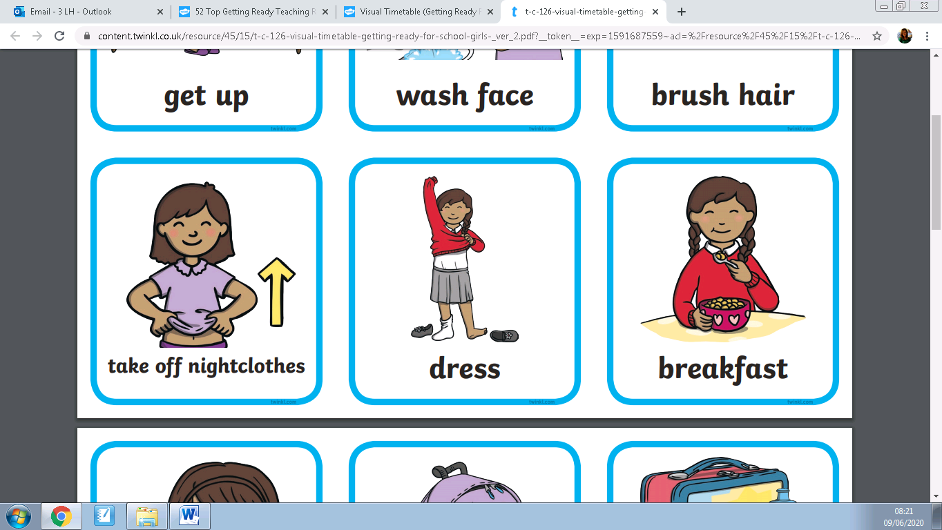

**I will still** have a morning routine at home.

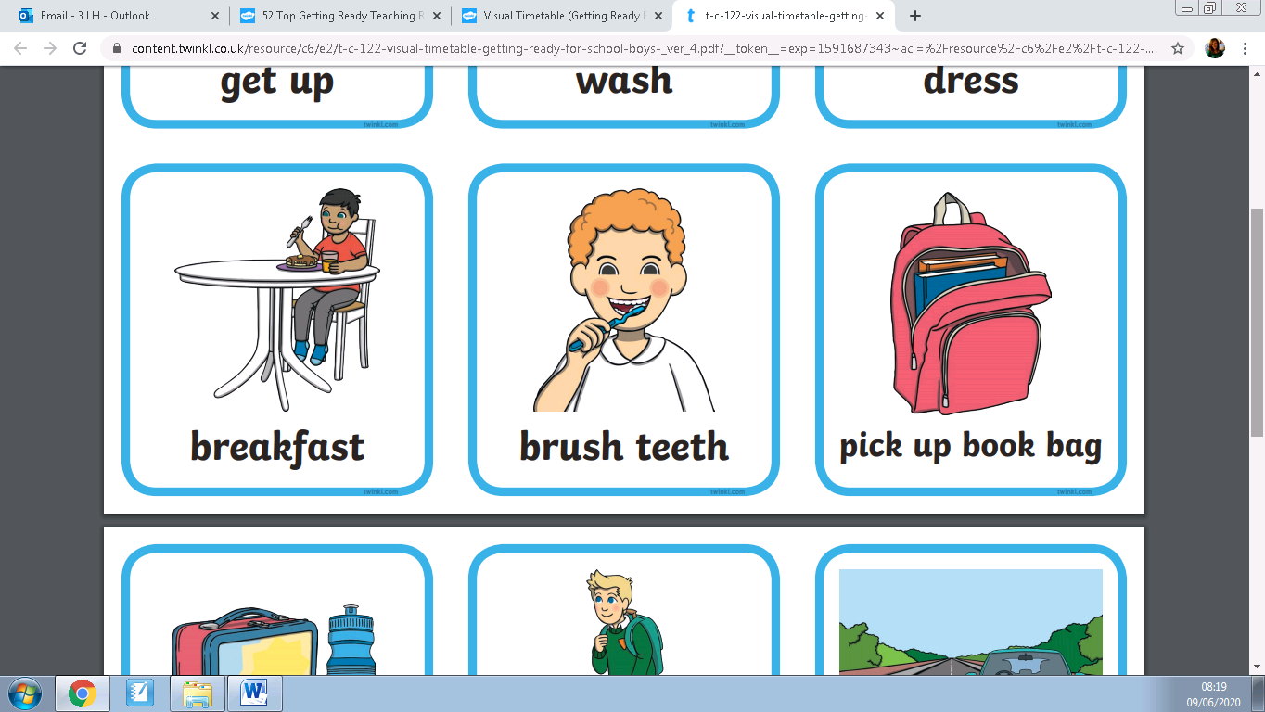

**I will still** wear a coat to school and have a place that I can keep my things.

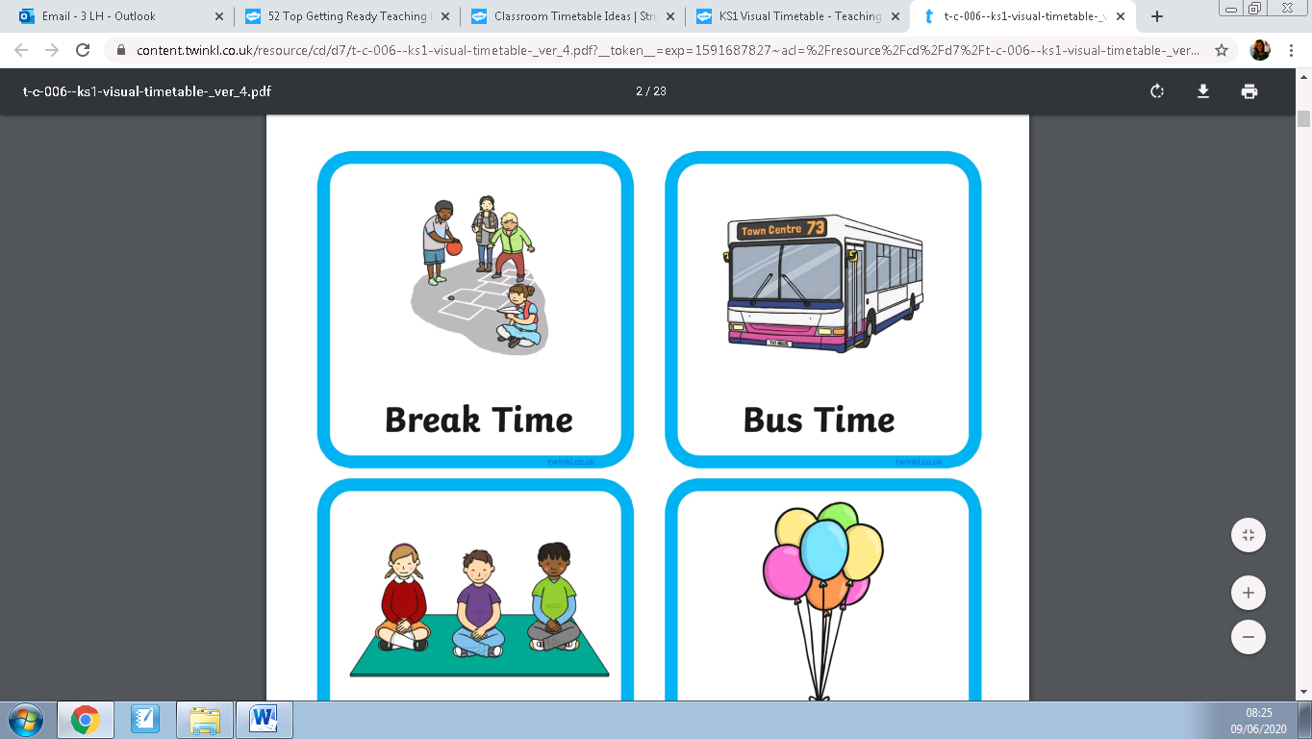

**I will still** have break times and can play with my friends.

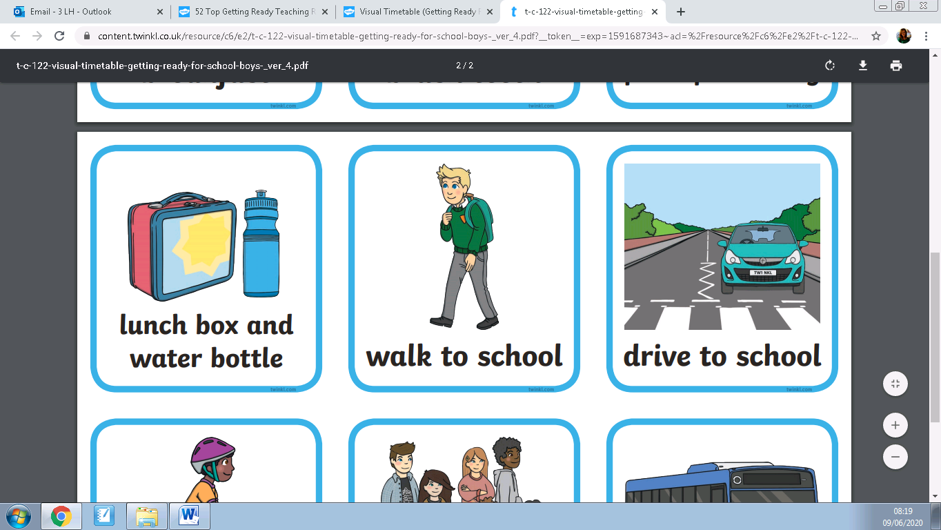

**I will still** have my lunch at school.

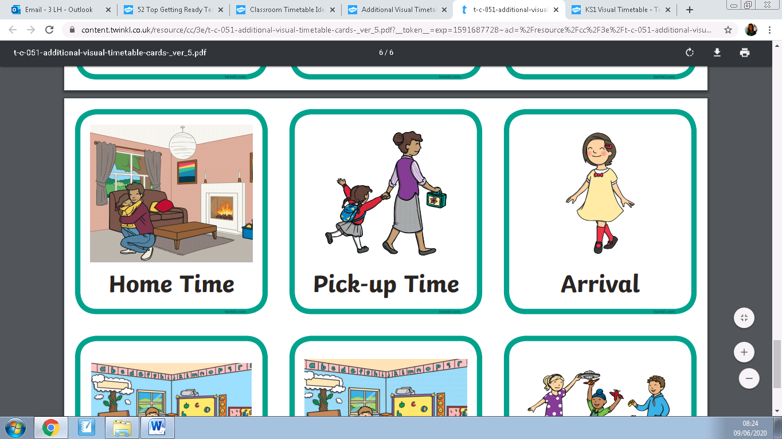

**I will still** go home at the end of the day.

Thinking about how you are feeling at the moment, write down

3 things you are excited about:



3 things you are nervous about:







In September, I will be going to PHJS. I will be in Year 3. I will wear a new uniform.

Draw a picture of yourself below in your new uniform.

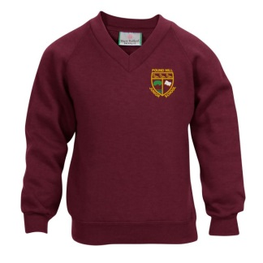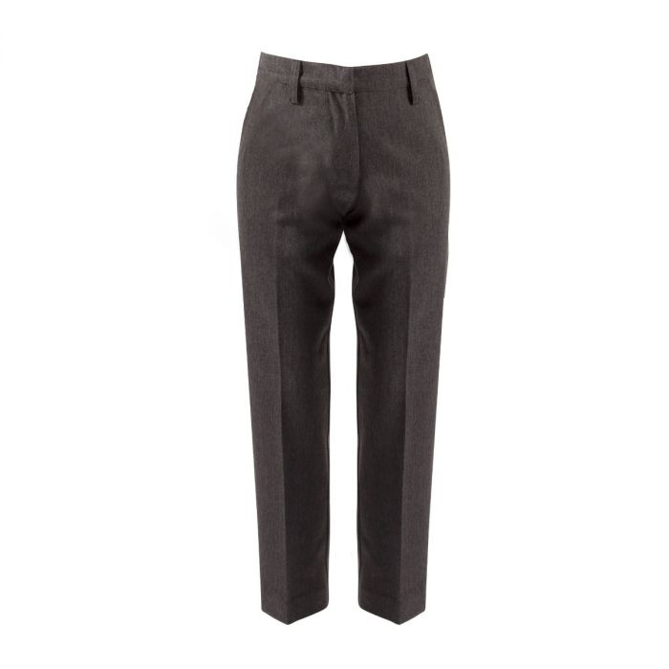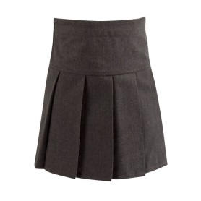

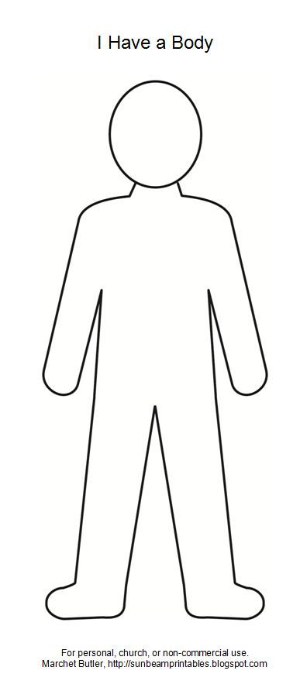

There will be 3 classes of 30.

The Year 3 teachers are __________________________________________________________________________________________

_____________________________________________

The Year 3 teaching assistants are _____________________________________________

_____________________________________________

My teacher will be ____________________________________________

Draw a picture of your new teacher

All the year 3 classrooms are downstairs. They are on one side of the corridor. Year 4 are on the other side.

When I get into school, I will put my coat, bag and lunchbox in my _____________

PLAYGROUND

Year 4

Hall

MR WHITE

**MS HATTON**

OFFICE

LIBRARY

Boys’ toilets

Girls’ toilets

Year 4

Year 4

Year 3

Year 3

Year 3

Medical

Room

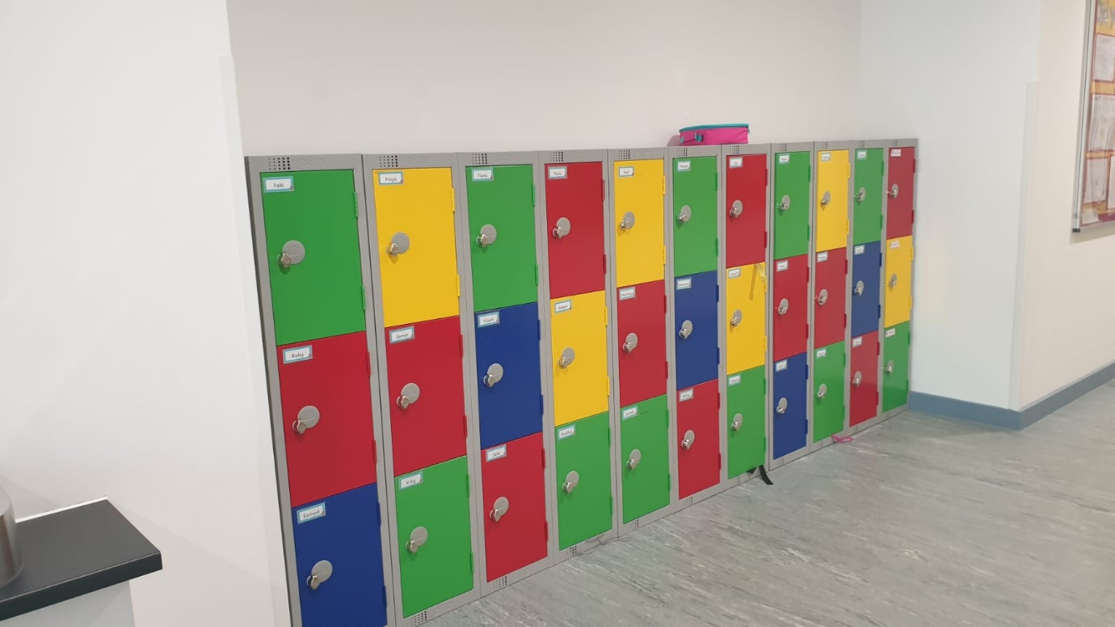The school day starts at _____________.

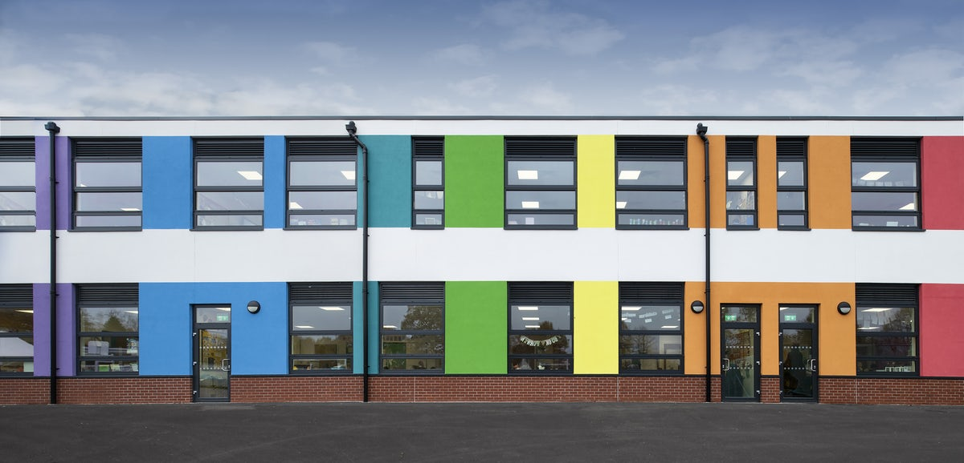I will meet my teacher on the playground. I will go in and out of my playground doors.

Year 3

Year 3

Year 3

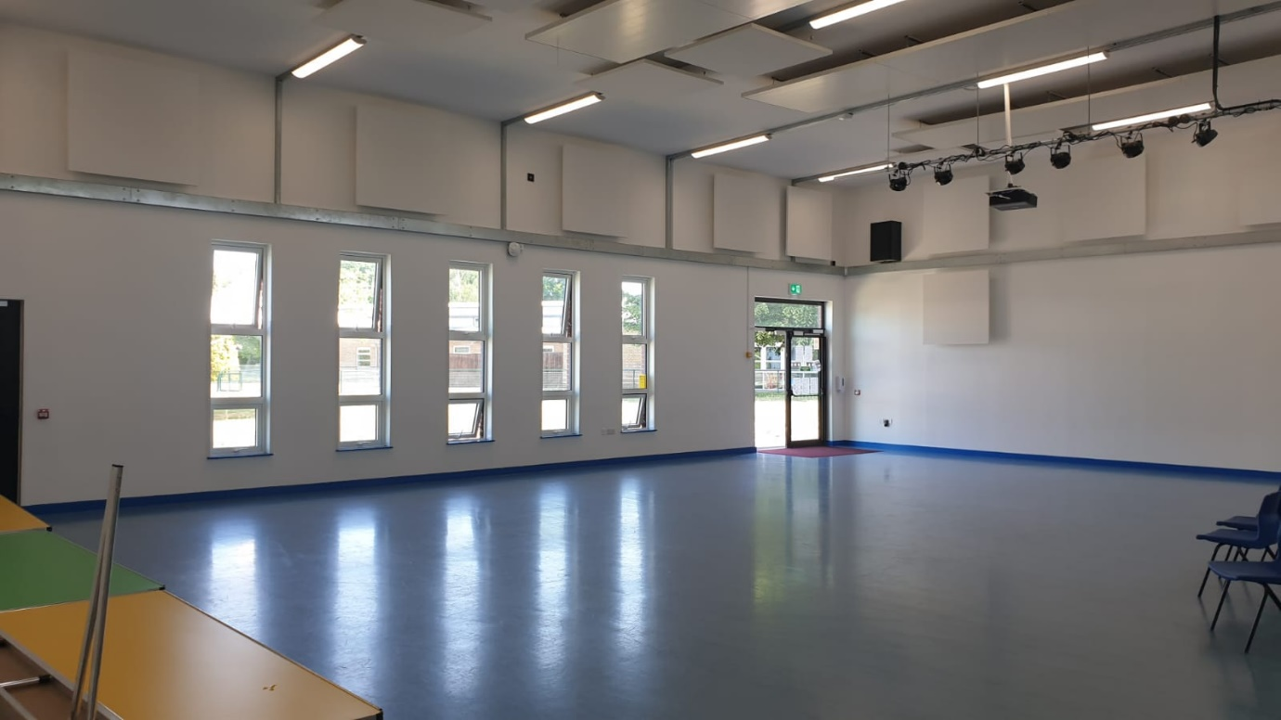On a Monday, Wednesday and Friday morning the whole school come to the hall for assembly.

In your classroom, you will have lots of different lessons.

Write down 5 lessons you think you will have. Many will be the same as in the Infant Academy.

__________________________________________________________________________________________  
_____________________________________________

_____________________________________________

_____________________________________________

3DL

Year 3

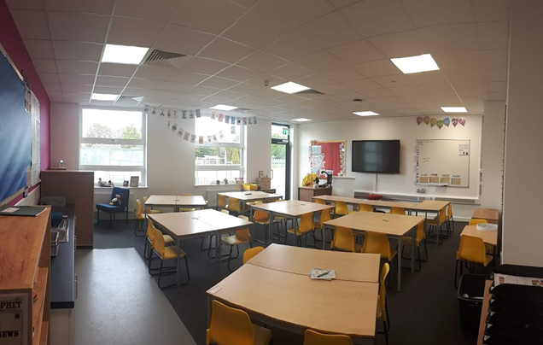

3SK

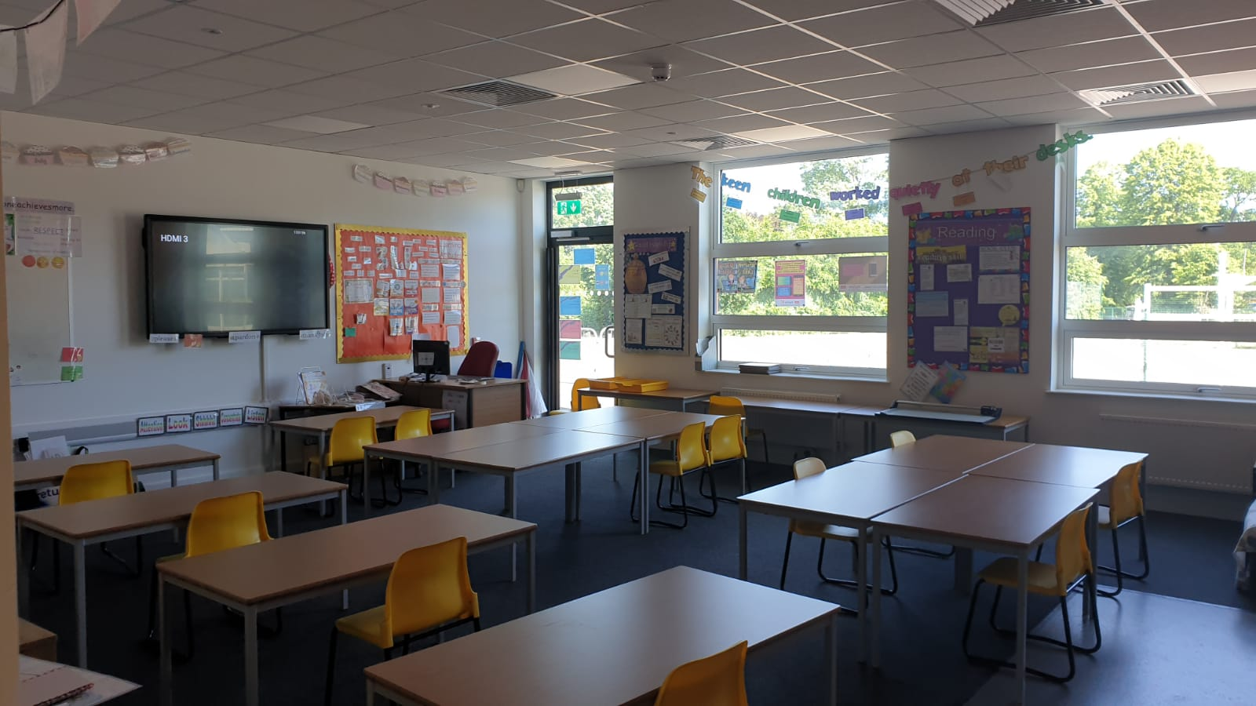

3SB

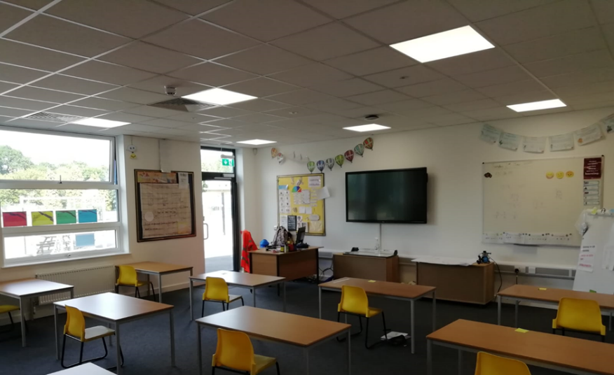

Once a week I will come to this classroom to learn French. My French teacher is called _____________________________________________

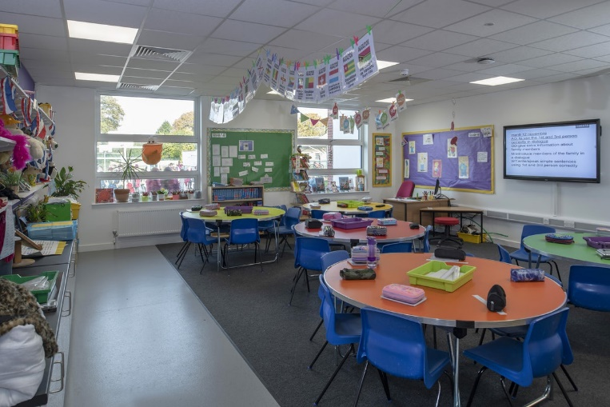

Bonjour

At playtimes, I will go out with Year 3 & Year 4.

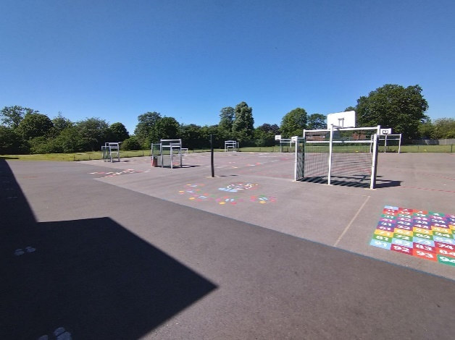

I like to play _________________________________ on the playground.

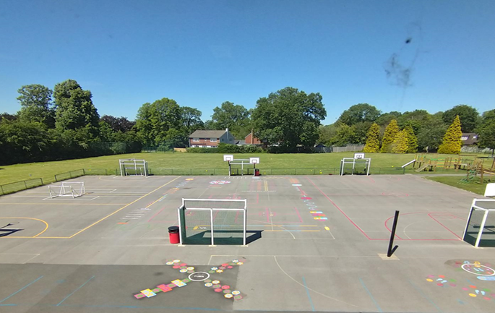

At lunch time, I will eat in the hall with another year group.

I can order a school lunch. This could be a hot meal, jacket potato or sandwich. School lunches are very tasty. Sometimes there are treat days where I will have fun meals such as burgers and pizzas. There is always fresh fruit, homemade desserts and yoghurt.

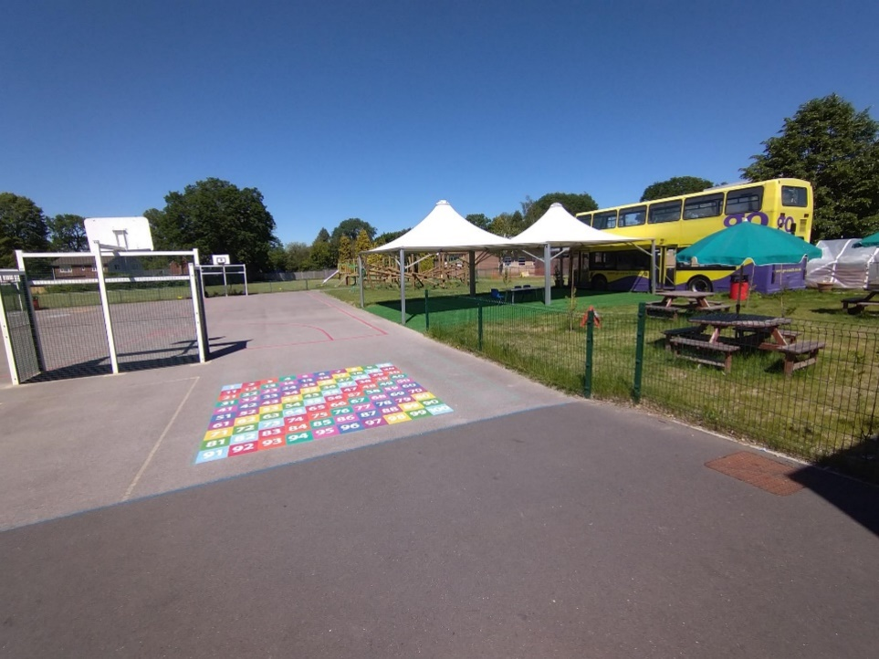

Either before or after my lunch, I can play on the playground (or field if the weather is nice).

The school day finishes at __________.

I will meet my parents on the ________________.

Questions I have about Pound Hill Junior School

