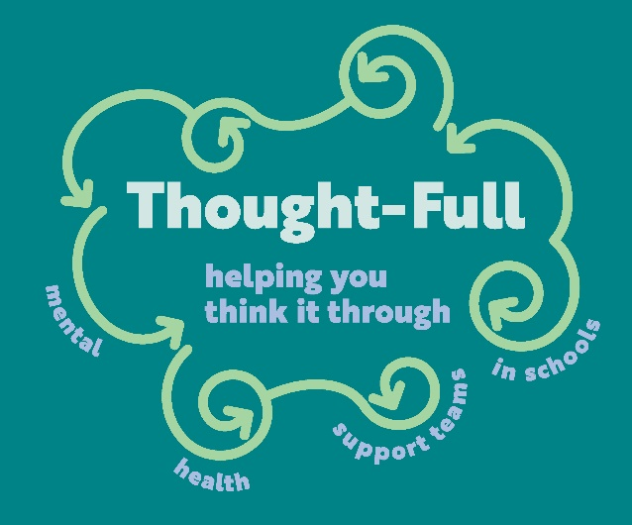

**Mental Health Support Teams in Schools**

**(MHST)**

**For more details visit our website**

[www.westsussex.gov.uk/Thought-Full](http://www.westsussex.gov.uk/Thought-Full)

**email us at**

[thought-full@westsussex.gov.uk](mailto:thought-full@westsussex.gov.uk)

**or find us on social media**

**Twitter**[@ThoughtfullMHST](https://twitter.com/ThoughtfullMHST)

**Facebook** [West Sussex Thought-Full](https://www.facebook.com/westsussex.mhst.9/)

**Instagram** [Thought-Full](https://www.instagram.com/wsthoughtfull/)

**Where possible please liaise with your school’s Senior Mental Health Lead (SMHL) before contacting us**

*Please note we are not in all schools due to funding constraints. There is a full list of schools on our website



**Thought-Full are The Mental Health Support Team in Schools in West Sussex.**

We are a joint commissioned WSCC and NHS team of practitioners working in Primary and Secondary schools supporting pupils, parents and school staff in a number of different ways.

We offer **training, workshops, interventions and** **consultations** to support schools to take a whole-school approach to mental health and emotional wellbeing

We also can support children and young people who are experiencing **low mood and/or anxiety,** **fears, worry, low self-esteem, sleep difficulties,** **eating problems** (linked to mood and emotional issues) and young children with **behavioural issues**.

We support children at the early stages of these difficulties when they are described as **‘mild to** **moderate’**. If problems are more complex then we will help school staff to find the right direction through **advice, support and signposting**.

**Our offer to schools focusses on 8**

**areas as set out by**

**Public Health England.**

