The Last Wild Book Review
By Lucian Haines Gilbertson 6BW

The Last Wild is an action packed book about a boy named Kester and how escapes from a place called Spectrum Hall. He goes on a quest to save all animals from a disease but I won’t spoil it for you!
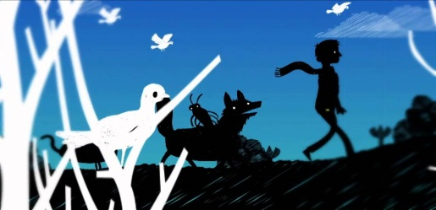
I rate it 5 stars *****
