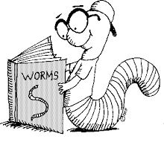
Reading

Reading expectations
A book a half term – 6 over the year.
- These books are to be a variety of different genres to broaden your language and experiences.
- I will expect to see you reading 10-15 pages a night, depending on the level of your book and these pages recorded in your homework diary each night.
- At the end of your book you will write a short summary to tell me some of the key events that have happened.
- If you do not finish the book during school time you will be given half term to catch up.
- I will speak to you individually if I have a different expectation than above.

Homework diary entries.
- You should write something about what you have read each night. These can be a variety of different things.
- Word meanings in context – pick a word from what you have read and tell me what it means.
- A question with a possible answer – write a question I could answer using the book, then write an answer.
- Connection with something else – what links to other books does it have?
- Author’s technique – What effect does it have on the reader.
etc...

