Maths in Year 6
A Parent Booklet

Pound Hill Junior School

Aims of this booklet:
- To increase understanding of Maths mastery at Pound Hill Junior School
- To increase understanding of the end of Year 6 expectations in Maths.
- To increase understanding of the Times Tables expectations and how they link to the national curriculum.
- To familiarise yourself with methods and strategies to support learning Times Tables at home.

Maths mastery at Pound Hill Junior School
Our aim for teaching mathematics at Pound Hill is to create a deeper understanding to ensure that all children have the fundamental skills and knowledge to succeed in their learning. By building on a solid foundation of number work, children are able to access a wide range of topics. This will support them, not only at our school, but in future life which underpins the purpose of maths stated in the National Curriculum: “It is essential to everyday life, critical to science, technology and engineering, and necessary for financial literacy and most forms of employment.”
Maths at PHJS is taught in mixed ability classes, where the class works together on the same mathematical concept. There are opportunities for support within the lessons through using resources and chances to develop at a greater depth through reasoning and more open-ended problems.
Through weekly in-depth marking, children will have the opportunity to challenge themselves further with a task linked to problem solving/reasoning or receive adult intervention to consolidate their learning from the previous lesson.
The aim of teaching with a mastery approach is to narrow the gap in attainment. Teachers will ensure children are supported and challenged in the best way through assessing their understanding during the talk for learning aspect of the lesson. Termly assessments allow for children to demonstrate their understanding in a different context and allow the teacher the chance to select key objectives that may need more reinforcing.
Our school’s calculation policy outlines fluency with number facts, mental calculations and written methods we would expect the children to be secure with by the time they leave Pound Hill. The use of empty box problems, contextualising the mathematics and questioning to develop mathematical reasoning will reinforce the learning that takes place at our school.

The Mathematical areas that a child needs to be secure in to be considered working at the expected standard are vast. Detailed below are the separate strands of Maths and individual statements that children are required to have learnt and mastered, in order to be working at the expected standard by the end of Year 6.

Working at expected standard (EXS)
The pupil can:
Number and Place Value:
- Read, write, order and compare numbers up to 10,000,000 and determine the value of each digit
- Round any whole number to a required degree of accuracy
- Use negative numbers in context, and calculate intervals across zero
Addition, Subtractions, Multiplication and Division:
- Multiply multi-digit numbers up to 4 digits by a two-digit whole number using the formal written method of long multiplication
- Divide numbers up to 4 digits by a two-digit whole number using the formal written method of long division and short division, and interpret remainders as whole number remainders, fractions, or by rounding, as appropriate for the context
- Perform mental calculations, including with mixed operations and large numbers
- Identify common factors, common multiples and prime numbers
- Use their knowledge of the order of operations to carry out calculations involving the four operations
- Use estimations to check answers to calculations and determine, in context of a problem, an appropriate degree of accuracy
Fractions, Decimals and Percentages:
- Use common factors to simplify fractions
- Compare and order fractions, including fractions > 1
- Add and subtract fractions with different denominators and mixed numbers, using the concept of equivalent fractions
- Multiply simple pairs of proper fractions, writing the answer in its simplest form
- Divide proper fractions by whole numbers
- Associate a fraction with division and calculate decimal fraction equivalents [for example, 0.375] for a simple fraction
- Identify the value of each digit in numbers given to three decimals places and multiply and divide numbers by 10,100 and 1000 giving answers up to three decimal places
- Multiply one-digit number with up to two decimal places by whole numbers
- Use written division methods in cases where the answer has up to two decimal places
- Solve problems which require answers to be rounded to specified degrees of accuracy
- Recall and use equivalences between simple fractions, decimals and percentages, including in different contexts.
Ration and Proportion:
- Solve problems involving the relative sizes of two quantities where missing values can be found by using integer multiplication and division facts
- Solve problems involving the calculation of percentages [for example, of measures, and such as 15% of 360] and the use of percentages for comparison
- Solve problems involving similar shapes where the scale factor is known or can be
- Solve problems involving unequal sharing and grouping using knowledge of fractions
Algebra:
- Use simple formulae
- Generate and describe linear number sequences
- Express missing number problems algebraically
- Find pairs of numbers that satisfy an equation with two unknowns
- Enumerate possibilities of combinations of two variables
Measurement:
- Solve problems involving the calculation and conversion of units of measure, using decimal notation up to three decimal places where appropriate
- Use, read, write and convert between standard units, converting measurements of length, mass, volume and time from a smaller unit of measure to a larger unit, and vice versa, using decimal notation to up to three decimal places
- Convert between miles and kilometres
- Recognise that shapes with the same areas can have different perimeters and vice versa
- Recognise when it is possible to use formulae for area and volume of shapes
- Calculate the area of parallelograms and triangles
- Calculate, estimate and compare volume of cubes and cuboids using standard units
Geometry:
- Draw 2D shapes using given dimensions and angles
- Recognise, describe and build simple 3D shapes, including making nets
- Compare and classify geometric shapes based on their properties and sizes and find unknown angles in any triangles, quadrilaterals and regular polygons
- Illustrate and name parts of circles, including radius, diameter and circumference and know that the diameter is twice the radius
- Recognise angles where they meet at a point, are on a straight line, or are vertically opposite, and find missing angles
- Describe positions on the full coordinate grid (all four quadrants)
- Draw and translate simple shapes on the coordinate plane, and reflect them in the axes
Statistics:
- Interpret and construct pie charts and line graphs
- Calculate and interpret the mean as an average
Problem Solving:
- Solve simple and multi-step problems in context, deciding which operation and method to use
Working at greater depth within the expected standard (GDS)
The pupil can:
Working Mathematically:
- identify and obtain necessary information to carry through a task and solve mathematical problems
- check results, considering whether these are reasonable
- solve word problems and investigations from a range of contexts
- show understanding of situations by describing them mathematically using symbols, words and diagrams
- draw simple conclusions of their own and give an explanation of their reasoning
- develop own strategies for solving problems
- use their own strategies within mathematics and in applying mathematics to practical context
- present information and results in a clear and organised way
- search for a solution by trying out ideas of their own

National Curriculum: Maths Programmes of Study:
Year 4:
Pupils should be taught to:
- ▪ recall multiplication and division facts for multiplication tables up to 12 × 12

The following areas of the Year 6 Curriculum statements outline the importance of having a secure knowledge of all times tables. When children have an ‘automatic’ access to times table facts (including division), they are able to access a breadth of further learning in other areas of the National Curriculum:
In Year 6, children are expected to learn how to:
- Multiply multi-digit numbers up to 4 digits by a two-digit whole number using the formal written method of long multiplication
- Divide numbers up to 4 digits by a two-digit whole number using the formal written method of long division and short division
- Perform mental calculations involving multiplication and division and large numbers
- Identify common factors, common multiples and prime numbers
- Use their knowledge of the order of operations to carry out calculations involving the four operations
Not only do times tables link to multiplication and division directly, a secure understanding also allows children to access other areas of the curriculum, such as
- Fractions, decimals and percentages
- Ratio and proportion
- Algebra
- Area
- Converting measurement
- Constructing pie charts
- Averages
Top Tips for times table practise at home!
Don’t SIGH…
Set small, easily achievable goals
Ignore distractions
Give yourself enough time

Times Tables Websites
Although they have not been fully implemented yet, there is a strong likelihood that the government times table tests will be administered on computer. Therefore, we would like the children to get used to typing numbers on a keyboard so we encourage the children to practise their times tables on a computer as well as written down or verbally.

In order to access websites and apps that support this, you can head to the school website, following the ‘Parents’ tab and then ‘Maths workshop- Times Tables’.
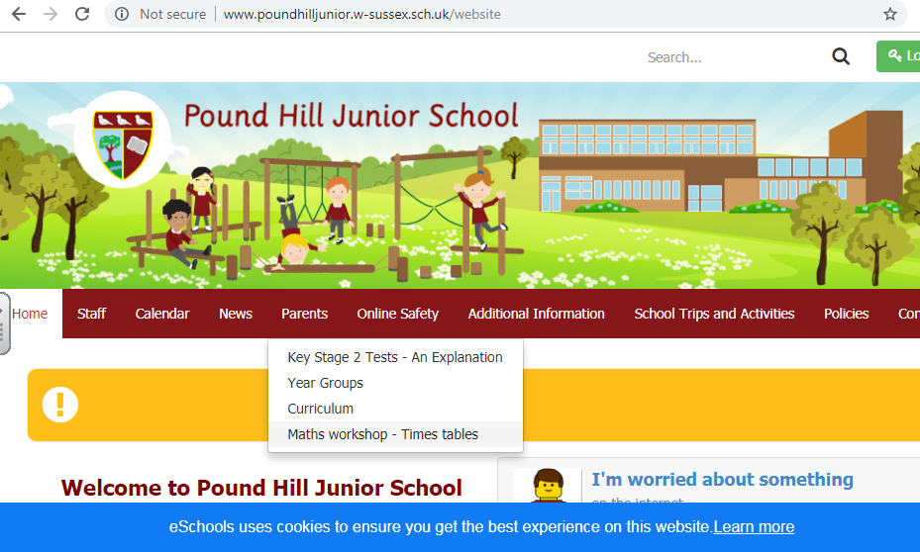
Click here
Alternatively the links to the websites are as follows:
https://www.topmarks.co.uk/maths-games/hit-the-button
https://www.nationwideeducation.co.uk/www/flash/bso/bso-flash/index.html
https://play.ttrockstars.com/
https://www.mathsisfun.com/numbers/math-trainer-multiply.html
Apps – Search for these in the App Store
- Squeebles
- Times Table Quiz
- 2 x 2 =4
These are but a few that are available. There are plenty of other times table apps that the children can use by searching through the app store.

Maths Reasoning
Reasoning questions are designed for a child to apply their understanding of all areas of mathematics in a variety of different contexts. They also aim for children to show understanding by selecting relevant information and present answers in a correct context.
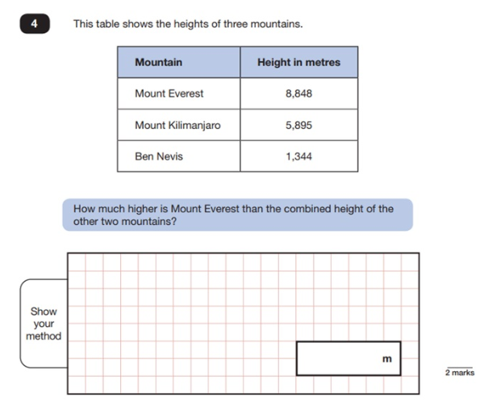

The question above expects the pupil to be able to add and subtract numbers in the thousands. Once they have recognised that there are two stages to the question, they should show their working out as a mark may be awarded for doing so, even if the answer provided is incorrect.

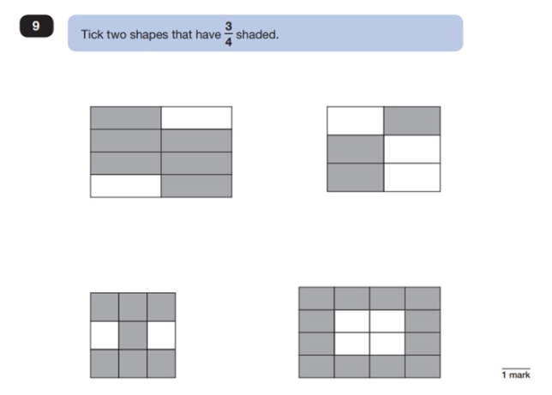

This question focuses on equivalent fractions. Children may easily recognise ¾ when the shape is divided into four equal parts and three are shaded. What they should also recognise, is that six out of eight, nine out of twelve and twelve out of sixteen all have the same value as three out of four. They should also recognise that those shaded sections do not necessarily need to be next to each other.
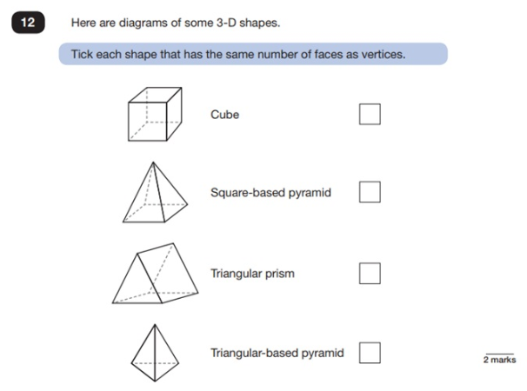
This question is a straightforward test of the student’s understanding of the language of geometry. ‘Faces’ are the flat surfaces that make up a three-dimensional shape, and ‘vertices’ are the points where two or more edges meet. If that knowledge is secure, this is a fairly straightforward question!
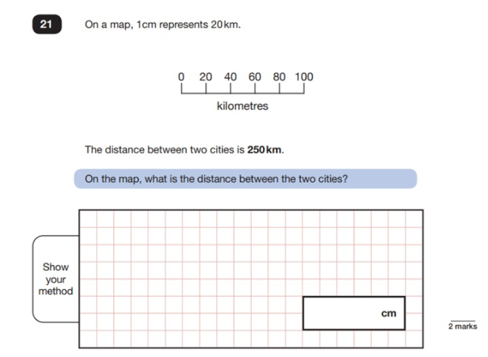
This is a question about scale and proportion. Again, it is a multi-step question. The child should first recognise that 1cm on a map represents 20km. They should then demonstrate evidence of an appropriate method, such as 250 ÷ 20 to achieve an answer of 12.5cm.
Other indications that the child has understood what the question is asking of them may include the following: 20km is 1cm, 100km is 5cm, 50km is 2.5cm. 5cm + 5cm + 2.5cm = 12.5cm.

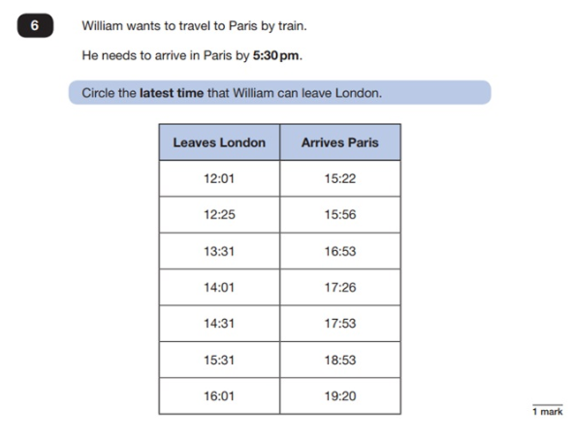
This is another example of a question set in context, this time using a timetable. Although children will be taught how to read timetables accurately, this question not only relies on their ability to read the timings, but also their ability to decide based on factors. William needs to arrive in Paris by 5.30pm and therefore the 14.01 train is the latest he should take. The potential stumbling block here would be if the child cannot translate times between twelve hours and twenty-four hours – although the question is asked using ‘pm’ the timetable is written using the twenty-four-hour clock.
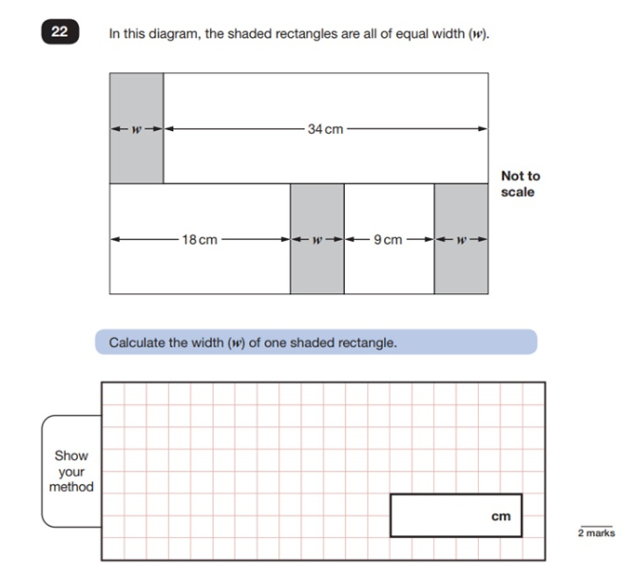
This is a really tricky question that relies on the child’s ability to manipulate numbers and, in actual fact, use algebraic equations to solve a problem.

If the child recognises that 18 + 9 + 2 widths = 34 + 1 width, or that 27 + 2 widths = 34 + 1 width (or even that 27 + 1 width = 34), then they should be able to conclude that 34 – 27 = 7, which is the width of one tile.
In effect, they are using algebra: 34 + w = 18 + w + 9 + w or 34 + w = 27 + w + w.

